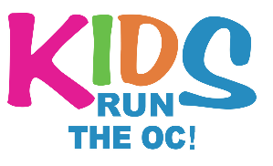INSERT SCHOOL LOGO HERE
2024 KROC [School Name] Training Program

(School Name) is excited to participate in the 2024 Kids Run the OC training Program through the OC Marathon Foundation. Below is all the pertinent information regarding our schools training program:
Coach’s Name and Contact Information: (Fill in school specific information here)
Program Start Date and Location: (Fill in school specific information here)
Practice Schedule, Dates, Times, and Locations: (Fill in school specific information here)

Registration Information
Register online at www.kidsruntheoc.org.
• Online registration is open until March 1, 2024.
• Please bring confirmation email and signed waiver to (Collector’s Name) by (date).

Race Day Information
May 4th, 2024
OC Fair and Event Center, 88 Fair Dr. Costa Mesa, CA 92626

KROC Contact Information
Coach Contact Information (For questions about your school, your practices, etc.):
Insert Coach Name Here • Insert Coach Email Here • Insert Coach Phone Here
Kids Run Program Information (For questions about The Final Mile Event + registration):
Kelsey Beall • kelsey@ocmarathon.com • 714-241-0142 ext. 1
Adrienne • adrienne@ocmarathon.com • 714-241-0142 ext. 4

